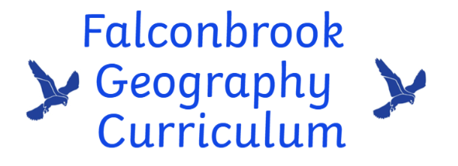Our curriculum

At Falconbrook, our Geography curriculum is designed to inspire children’s curiosity and fascination with the world around them. Through substantive and disciplinary knowledge, children will learn about how people influence and interact with the physical and human environment. Fundamental Geography skills are built upon through engaging units with a focus on fieldwork and the local area.

End points
By the end of EYFS, children will develop their awareness of the environment and world around us. They will develop some basic knowledge about their local area and use maps in play-based situations. They will develop their understanding linked to simple geographical contexts such as weather.

By the end of KS1, children will build on learning and language gained in Early Years. They will develop their knowledge of the different countries of the UK, continents and oceans of the world. They will understand basic geographical vocabulary and use it to describe physical and human features of places. Children will begin to use maps and fieldwork skills to explore their local area.

By the end of KS2, children will be able to locate and describe key geographical features and regions across world using different resources. They will understand physical and human processes and how these shape the environment whilst developing an awareness of sustainability, recognising how human actions impact the planet. Children will confidently carry out fieldwork, analyse data, and communicate their findings.

Curriculum Map
Nursery
Fairytales China
- Develop a sense of Food
place (settings) Celebrations
- Journeys Art

Reception
Exploring maps  - Map making  - Pirate maps  - Journey sticks | - Under the Sea  - What lives in the sea  - Exploring the ocean  - Caring for the ocean | South Africa  - Culture  - Animals  - Beaches
Year 1
Where we live  - Map skills  - Locational language  - Fieldwork | Weather and Seasons  - Location of the UK  - Weather & seasons in the UK  - Observing how the weather chages | Australia  - Physical features found in Australia  - Human features/landmarks  - Wildlife In Australia
Year 2
The UK and beyond  - Using maps and atlases  - Naming different countries in UK  - Naming and locating continents and oceans | Hot and Cold places  - The equator  - Where the hottest and coldest places are  - What it is like to live there | Jamaica  - Similarities and differences in a small area of Jamaica compared to Battersea
Year 3
Change in our local area  - Fieldwork  - Mapping changes  - Collecting data | Where our food comes from  - Trade  - Farms and factories  - Map food miles | Japan  - Physical features of Japan  - Mountains  - Volcanoes
Year 4
Exploring London  - Fieldwork  - London landmarks  - Tourism | Landscapes and places in Europe  - Using maps and atlases  - Human and physical features  - Compare Lake District with Catalonia | Brazil  - Features of Brazil  - Rainforest  - Impact of deforestation
Year 5
Rivers/River Thames  - Features of rivers  - River Thames  - Waterfalls | Trade across the globe  - Supply chains  - Local vs global  - Impact of trade | Kenya  - Landscape  - Water cycle  - Maasai community
Year 6
Our local area and Geography skills  - Maps  - Fieldwork  - Digital mapping | Sustainability:  - Energy  - Using resources responsibly  - Looking to the future | India  - Development and inequality  - Access to water, education and housing  - Regional differences
Disciplinary Knowledge
Enquiry skills – exploring how and why things are the way they are in different places
Collecting and analysing data – understanding how to gather information and developing skills to make sense of this
Communicating geographical information – learning to present findings in a variety of ways
Conducting fieldwork – observe, record and investigate world around them
Using maps and representation – learning to interpret and use various tools

